**Appendix D: Summary of Municipal Actions - Township of North Dumfries**

Within the TransformWR Strategy, there are a total of 78 action items outlined in the 10 Year Plan.

Of these 78 action items, the Township of North Dumfries has responsibilities outlined in the following ways:

* Lead organization for 24 action items
* Collaborating organization for 4 action items
* Supporting organization for 4 action items
* Participating organization for 14 action items

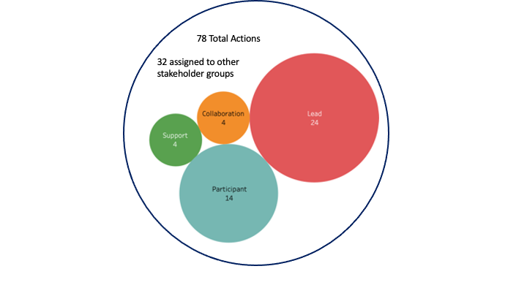

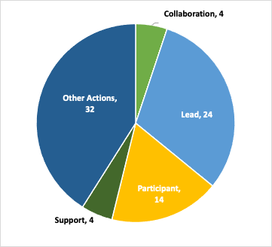

The following table shows the specific action items associated with the Township of North Dumfries.

**Lead Organization:**These organizations will take the lead on planning and implementing the action item, gathering support, and identifying additional collaborators or supporters to drive progress. They will also lead the identification and monitoring of success metrics through the ClimateActionWR collaborative.  
*Note: Many action items name more than one Lead organization, and in most cases where a municipality is identified, all Area Municipalities and often the Region of Waterloo are also listed as Leads.*

| **Action** | **Role** |
| --- | --- |
| Action 1.1.1: Plan a network of major active transportation corridors across cities and townships, that will provide high-volume priority travel for walking, cycling, and rolling to key destinations across the region, as well as access to public transit. | Lead |
| Action 1.1.2: Plan for and build neighbourhood connections to the active transportation network. | Lead |
| Action 1.1.3: Implement further policies across the region to prioritize active transportation in road and trail design and reconstruction. | Lead |
| Action 1.1.4: Identify and implement policy and program opportunities to de-incentivize driving. | Lead |
| Action 1.1.5: Design and maintain active transportation infrastructure to ensure year-round access, safety, and comfort for people of all abilities. | Lead |
| Action 1.2.4: Connect people to intercity, multimodal, and emerging transportation solutions. | Lead |
| Action 1.3.1: Launch micro mobility systems (bike, e-bike and e-scooter-sharing systems) in Waterloo Region communities. | Lead |
| Action 1.3.4: Develop active transportation and transit programs that target equity-deserving communities. | Lead |
| Action 1.5.1: Create “15 minute neighbourhoods” where people can meet their daily needs by walking, cycling, or rolling. | Lead |
| Action 1.5.2: Implement design standards for new developments to build for walking, cycling, and rolling to be the primary mode of travel. | Lead |
| Action 2.1.2: Plan and begin to implement a transition to zero emission vehicles for municipal fleets, working towards a goal of at least half of municipal vehicles being zero emissions by 2030. | Lead |
| Action 2.2.2: Require all new residential parking spaces, and a portion of new non-residential parking spaces, to be constructed as "EV-ready". | Lead |
| Action 3.1.9: Offer innovative loans for energy-related residential and commercial building upgrades. | Lead |
| Action 3.2.3: Develop region-wide building standards to encourage and support zero-carbon development of all new buildings in the region. | Lead |
| Action 3.2.4: Incorporate energy planning considerations into the development application review process. | Lead |
| Action 3.2.7: Show leadership by building net-zero carbon in the public sector. | Lead |
| Action 4.2.1: Implement community waste reduction and circular economy campaigns. | Lead |
| Action 4.2.4: Reduce unnecessary building demolitions and construction waste. | Lead |
| Action 5.1.1: Continue to develop and enforce robust land use planning protections for prime agricultural land. | Lead |
| Action 5.3.1: Support the reduction of GHG emissions from livestock, and develop methane capture and energy production from manure. | Lead |
| Action 6.1.1: Establish metrics to measure progress on increasing equity through GHG reduction initiatives in our community. | Lead |
| Action 6.1.3: Fund a climate justice committee led by community members from equity-seeking groups. | Lead |
| Action 6.1.5: Collaborate with Mennonite communities in the rural townships to build customized energy transition support to meet their unique needs. | Lead |
| Action 6.5.1: Bring community organizations and local government together to collectively identify and communicate advocacy priorities to multiple levels of government. | Lead |

**Collaborating Organization:**These organizations will work with the lead organization to drive progress toward the goals/metrics, and contribute to the reporting process as relevant to their work.

| **Action** | **Role** |
| --- | --- |
| Action 1.2.2: Ensure priority access for walking, cycling, and rolling to transit stations and bus stops. | Collaboration |
| Action 1.3.3: Create community active transportation hubs to provide customized support, education, training, and resources. | Collaboration |
| Action 2.1.1: Complete a region-wide electric vehicle strategy. | Collaboration |
| Action 3.1.10: Create a one-window service to support energy-related upgrades for homes and businesses. | Collaboration |

**Supporting Organization:**These organizations will provide support to the lead and collaborating organizations, on an as- needed basis, to drive progress toward the metrics associated with the action items.

| **Action** | **Role** |
| --- | --- |
| Action 1.4.1 Increase the efficiency of commercial goods movement. | Support |
| Action 2.1.5: Develop and implement an electric vehicle public outreach and communication strategy for personal vehicles. | Support |
| Action 3.1.5: Identify and implement necessary supports to transition anyone still using fuel oil, or propane for heating to other fuel sources by 2025. | Support |
| Action 6.1.4: Provide specialized resources/support to organizations on prioritizing equity while planning their transition. | Support |

**Participating Organization:**Being listed as a Participating Organization means your municipality will have a role in conducting this work from the perspective of an organization, in the same way that other organizations and businesses within the community are being asked to participate in these action items.

| **Action** | **Role** |
| --- | --- |
| Action 1.3.2: Expand and innovate on existing programming (e.g. Travelwise) that supports employers and employees in making active transportation and transit the easy and preferred choice for commuting and business travel. | Participant |
| Action 1.3.5: Post-pandemic continued adoption of work from home and flexible work schedules for reducing trips or shifting trips to off-peak times. | Participant |
| Action 1.5.3: Site key community services, health facilities, subsidized housing, etc., in central areas where they can be easily accessed using the active transportation and public transit systems. | Participant |
| Action 2.1.3: Plan and begin to implement the transition of commercial vehicle fleets to zero emissions vehicles. | Participant |
| Action 2.2.1: Provide more public electric vehicle charging stations in public spaces, commercial spaces and other places visited by the public. | Participant |
| Action 3.1.2: Implement a public literacy campaign to explain and promote the adoption of electric heat pumps for space and water heating in residential and commercial buildings. | Participant |
| Action 3.1.3 Switch home and business heating and water heating off of fossil fuels. | Participant |
| Action 3.1.6: Install renewable energy generation in business and residential buildings. | Participant |
| Action 4.1.3: Support the use of compost/organics collection programs for all commercial buildings. | Participant |
| Action: 5.4.2: Provide a variety of low GHG food options plant-based dining options in local restaurants, grocery stores, and catered events. | Participant |
| Action 6.1.2: Incorporate education on sustainability justice and equity into climate action planning. | Participant |
| Action 6.1.6: Build reciprocal relationships between Indigenous groups and local municipalities and climate action organizations to ensure GHG reduction work is done in equitable ways that respect the land and traditions of Indigenous groups. | Participant |
| Action 6.1.8: Apply an equity lens to all the actions in this transformation. | Participant |
| Action 6.3.4: Evaluate how to identify and protect optimal areas for industrial-scale renewable energy generation. | Participant |